Own proposal VCS2 Hugo Leenen

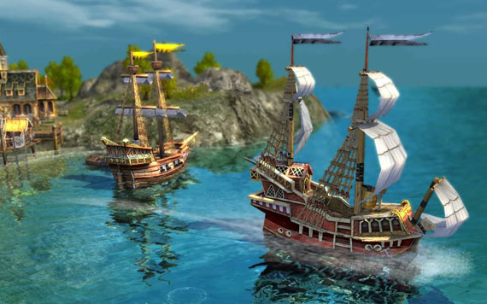How do you visualize and control a boat traffic controller?

The goal of the project is to create a VR application where the user is able to setup trade routes between different islands, while using the Vive controllers.

I want to create this application to learn about visualisation while not in the first-person perspective.

I want to be judged on how easy it is to interact with the application. And how easy it is to move around in the environment.  
I want to present the result with a demo presentation much like the individual assignment for ved1.

I am planning to work for about 28 hours. And I am planning to finish it around week 16.

I already know how to create a simple simulation were different 3d objects can move around.  
What I don’t know a lot about is controller interaction outside touching objects to pick them up.  
I will need to learn more about different 3d menus that you will have to hide when they are not relevant for instance, specific properties of a trade route should not be shown when looking at a lot of ships because the screen will fill up.

I am planning to look at a few different tutorials about 3d menus and I am going to show some other students to ask them for feedback.

